**Case Study - Ammy’s Job hunting**

**Introduction**

Ammy is a Human Resource professional in her company. Some data was shared with her relating to different aspects of the employed human resources in the company. It’s her take to analyze that data, make different comparisons and visualize different charts, to better understand and interpret this data. Ammy requests your assistance in analyzing the data using the excel sheet and inferring key points about the people working in her company.

**Problem Statement**

Ammy wants you to use the data to figure out a few things about the company, especially if the company’s attitude towards its employees is positive or not based on their salaries, date of joining, bonuses, etc.

Ammy asks you to help her analyze 3 important features of the company:

* Average salaries of employees
* Bonuses given to employees
* Which department is the best to work in?

You can inspect the entity relationship diagram and example data below.

Example Datasets

…..

Columns 1-5: The first two columns indicate the employee IDs and their Full names which Ammy doesn’t really care about. Ammy is more interested in their Job Title, Department and Business Unit.

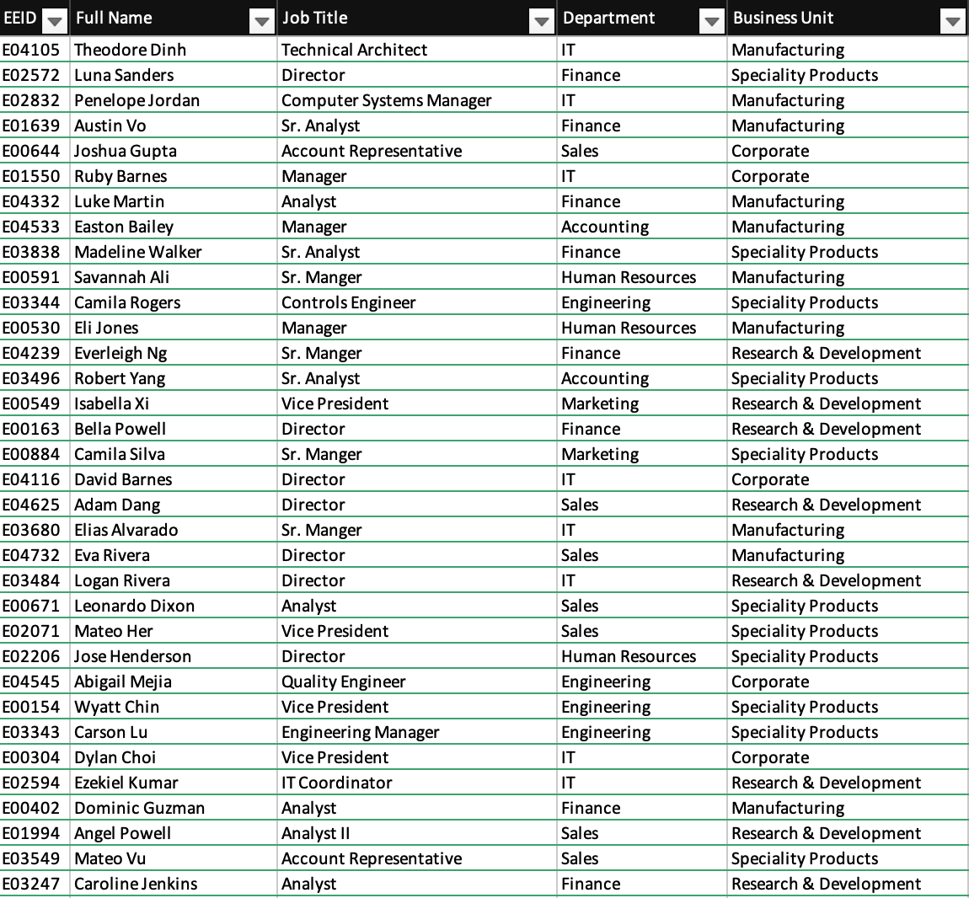Show more

Columns 6-14: It contains multiple columns of interests such as Gender, Ethnicity, Age, Hire Date, Annual Salary, Bonus%, Country, City, and Exit Date.

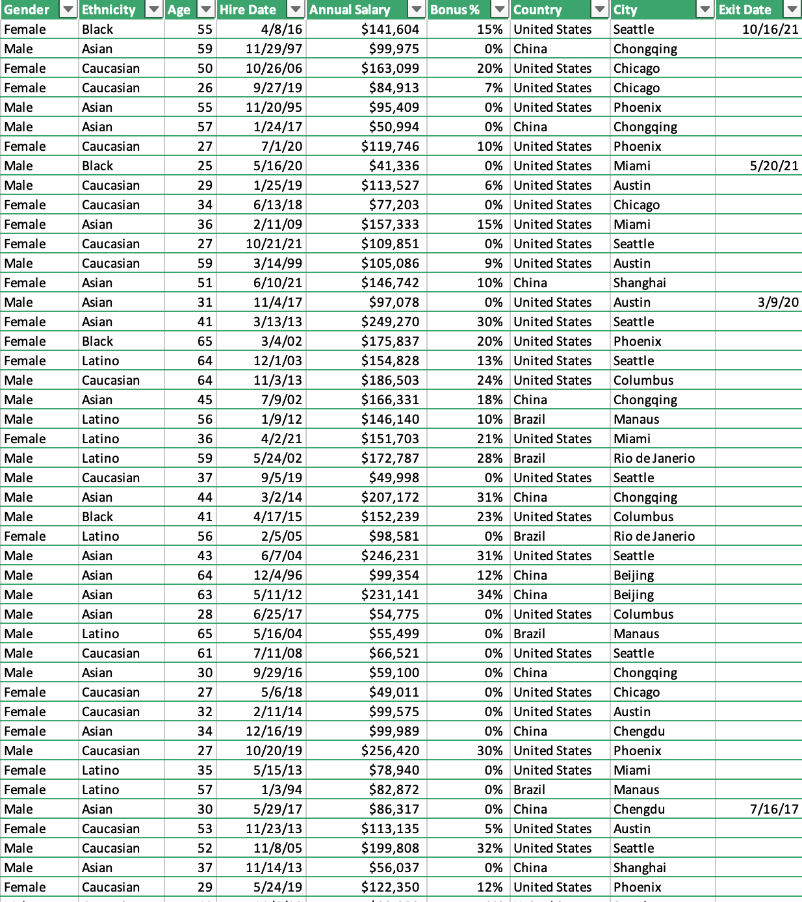

**Case Study Questions**

Each of the following case study questions can be answered using Excel:

1. Display the graph of Annual salary vs Department.
2. Display the graph of Annual salary vs Job title.
3. Create a Descriptive Statistics table for Age Column.

* Mean
* Standard Error
* Median
* Mode
* Standard Deviation
* Sample Variance
* Kurtosis
* Skewness
* Range
* Minimum
* Maximum
* Sum
* Count

1. Display the graph of Annual salary vs Gender.
2. Display the graph of Annual salary vs country.
3. Display the graph for Business Units vs. Gender.
4. Display the graph for Business Units vs. Annual Salary.
5. Display the graph for Business Units vs. Departments.
6. Display the graph for Business Unit vs. Age.
7. Create a graph for Hire date and Bonus received.
8. Generate a graph of the Average bonus vs Business Unit.
9. Generate a graph of the Average bonus vs Department.
10. Generate a graph of the Average bonus vs Job Title.
11. Generate a graph of the Average bonus vs Gender.
12. Create a Pie chart, Bar graph and a density graph for comparing count of ethnicity against department.
13. Create a graph comparing average Annual Salaries with Departments.
14. Create a graph comparing count of Countries and Cities.
15. Generate a chart of Average bonus vs Gender.
16. Create a column by merging Country and City.
17. Create an analysis table for the Annual salary column.
18. Create a column Total days which counts total days.
19. Create a column by combining Full name and Job title.
20. Create a column for Network days by utilizing hire and Exit dates.

**Bonus Questions**

1. Plot a boxplot of Annual Salary vs Business unit to find the maximum earning unit.

**Next Steps**

It’s highly recommended to save all your code in a separate IDE or text editor as you are trying to solve the problems in the provided SQL Fiddle instance above!